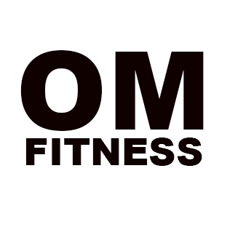
One Moore Fitness
706.631.2666
info@mobilemealsatl.com

Meal 1 | 5 Egg Whites & Oatmeal
Meal 2 | ¼ cup Cashews, Almonds, or Walnuts & Mass Gainer
Meal 3 | 5 oz Protein, 1 cup Vegetables & 1 cup Carbs
Meal 4 | 5 oz Protein & 1 cup Carbs
Meal 5 | 5 oz Protein, 1 cup Vegetables & 1 cup Carbs
Meal 6 | Mass Gainer & Casein Protein
*Must eat every 2 to 3 hours to maximize results!!!
Food Choice Recommendations:
Proteins – White Fish, Salmon, Tuna, Chicken Breast, Turkey Breast, Ground Turkey, lean cuts of Beef and Egg Whites.
Fruits – Grapefruit, Granny Smith Apples, Peaches, Pears, any type of Berries, Plums, Prunes, Papaya, Oranges, Cantaloupe, Honeydew, Kiwi, Banana, Cherries, Figs, and Lemon/Lime.
Vegetables – Asparagus, green leafy Lettuce, Greens Beans, Peppers, Spinach, Onions, Tomatoes, Cucumbers, Cauliflower, Celery, Collard Greens, Cabbage, Broccoli, and Zucchini.
Carbs – Sweet Potatoes, Yams, Brown Rice, Oatmeal, Black Beans, Red Beans, Quinoa, 100 % Whole Wheat Pasta, 100% Whole Wheat Sandwich Wraps, and 100% Whole Wheat Breads.
Healthy Fats – Almonds, Walnuts, Cashews, Nut butters (almond, peanut, and cashew) and Avocados

Tips
- Nut butters should be all natural, the fresher the better. You may add honey to sweeten to taste.
- Avoid canned goods.
- Buy fresh or frozen fruits and veggies.
- Avoid pre-packaged meats.
- Avoid fruit juices with high sugar content.
- Limit the intake of processed foods, fast foods, pre-packaged foods and dried fruits.
- Green Veggies are UNLIMITED!!!

*** The plan consists of six days of clean eating with one day off each week. On your day off you are allowed one “free/cheat meal”, the rest of the meals and snacks consumed should be in accordance with the suggested foods outlined above ONLY.

DISCLAIMER: This is a suggested meal plan and individuals that comply with this meal plan do so at your own discretion. The meal plan is prescribed from a knowledgeable personal trainer’s perspective with over 10 years of experience, not from the perspective of a dietician.

